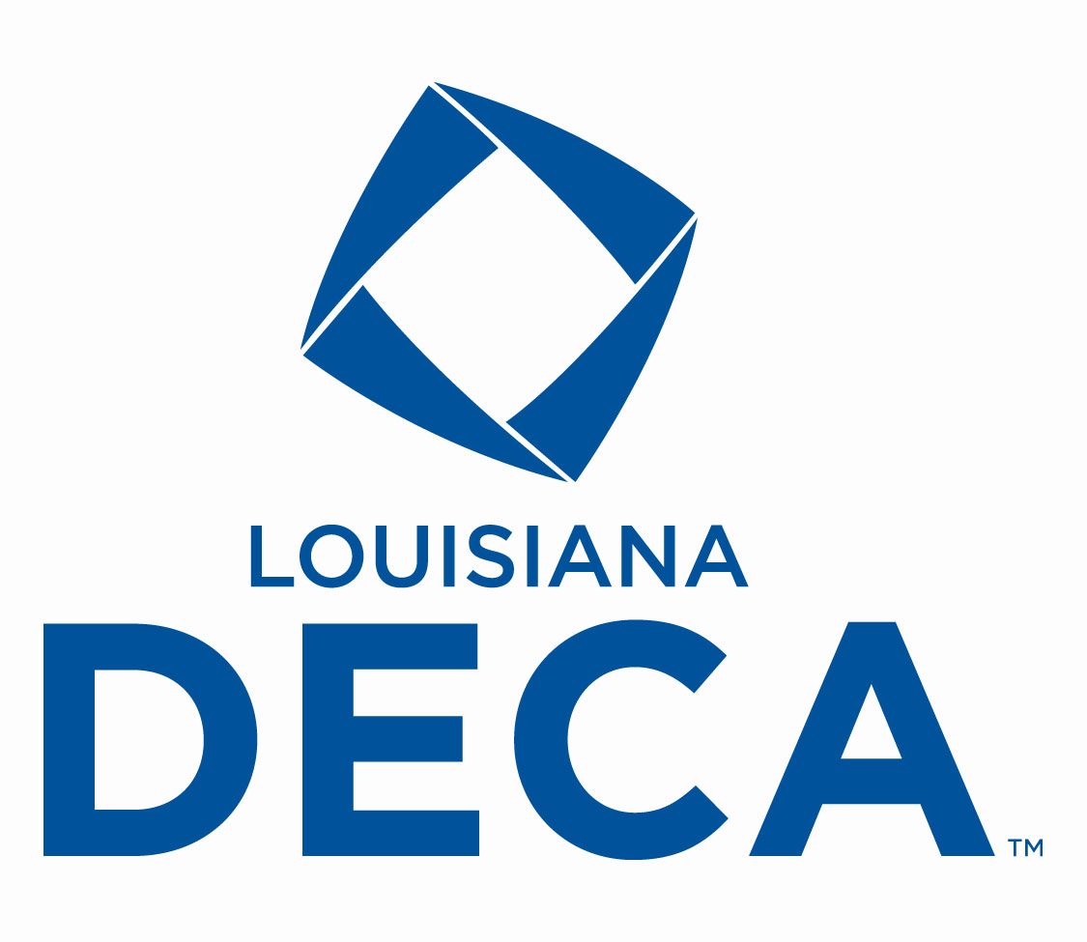
LOUISIANA DECA
SCHOLARSHIP

BUSINESS DONATION

One way you can get involved in helping Louisiana DECA’s Scholarship Program is to make a donation to the scholarship fund.
There are two scholarships. One is open to any graduating senior member of DECA. The second one is only open to a graduating state DECA officer.

We are looking for a donation in one of the following categories:

DECA Bronze--$50 donation
DECA Silver----$100 donation
DECA Gold-----$200 donation
DECA Platinum---$500 donation

With your donation to the DECA Scholarship Fund, your business will receive recognition in many ways at the state conference. Your company name will appear in the state program (1/8 of page ad in program for bronze level, 1/6 of page for silver donation, and 1/4 of page for gold level donation, and 1/2 page for the platinum level), be announced with the scholarship, and be shown in the video production shown during the conference. Also, you name will appear on the award plaque. Please make your donation to Louisiana DECA by February 20.

An invoice for you to complete is attached.
LOUISIANA DECA
SCHOLARSHIP DONATION

INVOICE

Our business would like to assist Louisiana DECA with the two scholarships to be given each year at the state conference. Our information is below:

Business Name
Business Address
Business City, State & ZIP
Contact’s Name
Phone #
Check Donation Category
◻ | DECA Bronze--$50
◻ | DECA Silver--$100
◻ | DECA Gold--$200
◻ | DECA Platinum--$500
Enclosed is our check  payable to La. DECA  in the amount of | $

Mail your donation and a copy of this form by February 20 to:
Louisiana DECA
13967 J R Drive
Walker, LA 70785
Tax ID #: 72-6025338

